How to make a Nanotechnology Kit -- January 2009

This kit is based on SRI's "NanoSense" Curriculum
(www.nanosense.org)

by

Jesus Contreras and Maureen Scharberg*
San Jose State University

Funding provided by: National Science Foundation (ESI-0426319) and UC Santa Cruz’s Bio-Info-Nano Research and Development Institute.
*Manual written by Jesus Contreras, SJSU Undergraduate majoring in Electrical Engineering. For more information, please contact Maureen Scharberg at Maureen.Scharberg@sjsu.edu.

The list of each material used for the kits and where you can purchase each item will be given on the last page of this document.
First, we begin with the container. The container (below) has dimensions of 16.5x11x10.4 inches, which is roughly 19 qt or 17.9 L. The one shown below made by Rubbermaid and purchased it at Target.
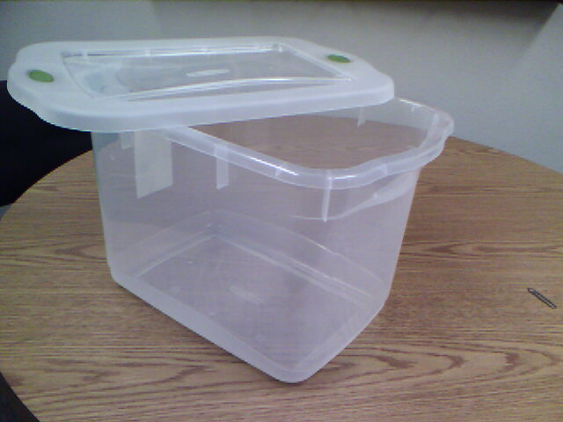
There will be a lot of glue attached to this kit and information regarding a step-by-step process in creating this Nanotech kit. You will need an art supply glue gun with plenty of glue gun sticks.
The first process is to attach the Preform Test Tube Rack (first picture shown left below) inside of the container using a glue gun and glue sticks. It’s hard to attach the tube rack because the container is not perfectly flat on the bottom. Picking one of the sides, place the rack against the longest side of the container. The black circles on each picture indicate where you should put glue. You may need to place more glue to secure the rack. Please see page 6 for more suggestions for gluing the rack to the container.
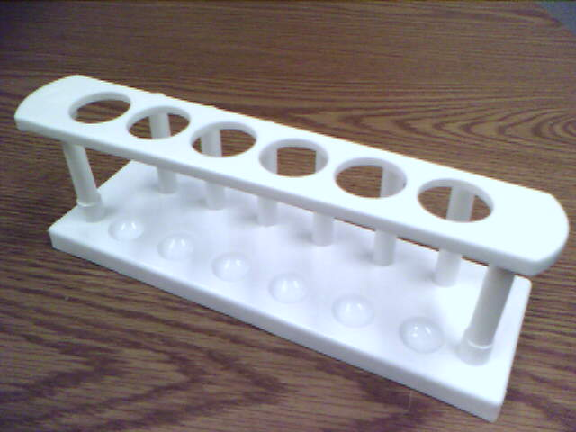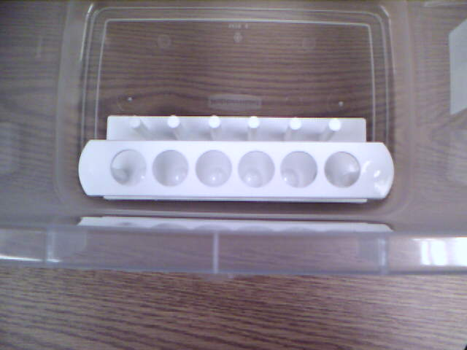

The following pictures will have more areas to apply the glue for the rack to the inside of the container:
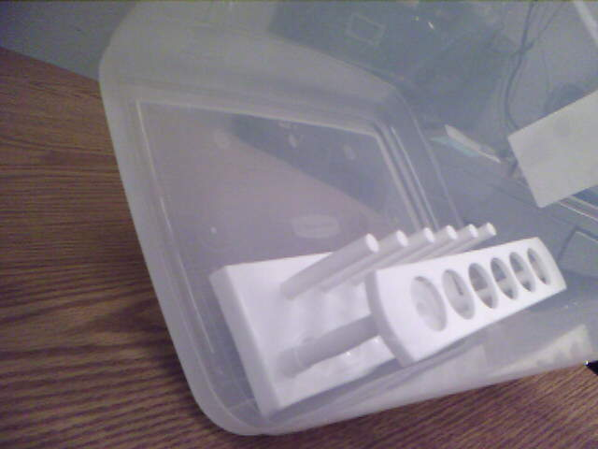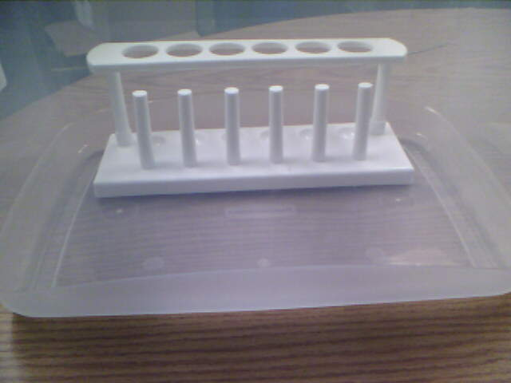
The glue should take approximately 10 minutes or more to dry. The picture on the left will also need glue on the other side of the rack. Double check to make sure the rack is firmly attached to the bottom of the container. You might need to place additional glue for the rack as shown on page 6 of this manual.
For the Ferrofluid (F.F.) to be transported, we will need a plastic water bottle (20 oz. preferred), 2 ceramic magnets and poly foam (pictures below).
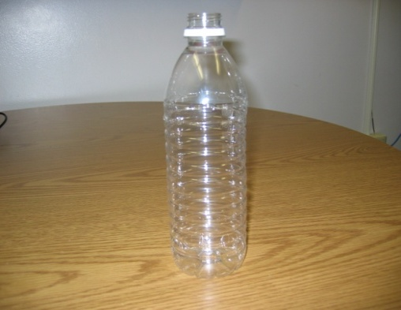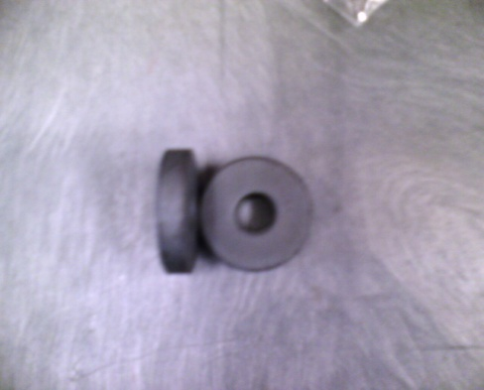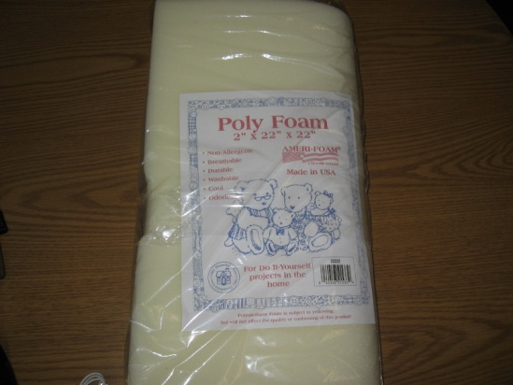

Note: The F.F. must be turned upside down (cap side down) because it will preserve the longevity of the tiny “nanosized” iron particles. (The Ferrofluid will be discussed in this manual later.)

The plastic bottle must be cut off (towards the top) so that the F.F. display would fit (pictures shown below):
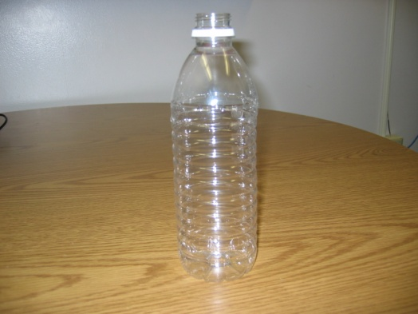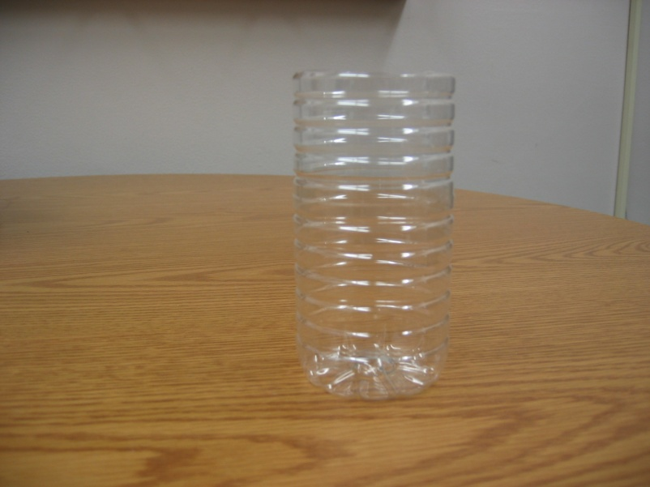

A glue gun, glue sticks and sewing scissors will be needed for the few steps. The first step is to glue two ceramic magnets inside the center of the plastic bottle (it should align to the knob of the bottle; depending on what bottle is used) and should look like the two pictures below:
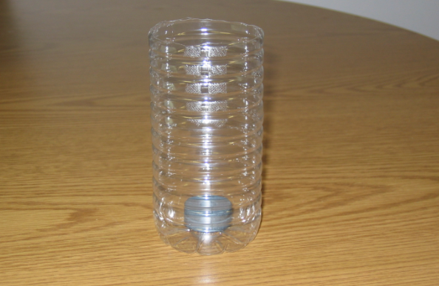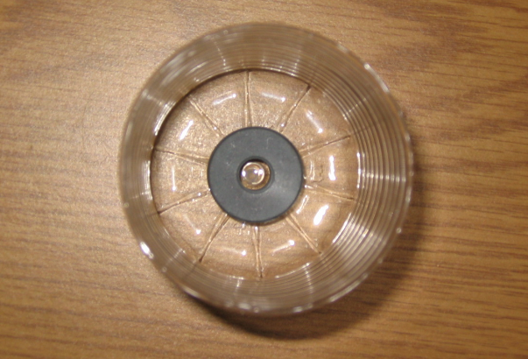
The glue should take at least 3-5 minutes to dry. The Poly Foam (pictures shown on the next page) then should be put cut in half (the dimension of the FULL foam bought is 2” x 22” x 22”) so that the foam can fit around the magnet and inside the plastic bottle. (For the foam, I used sewing scissors because they are very sharp and cut more efficiently than regular scissors.) This will make the F.F. display compressed and less likely to move when being transported. (Note: You can glue the foam onto the bottle, it depends if you would like to or not, this will cause deformation of the bottle because the glue is hot, so it melts the plastic.)
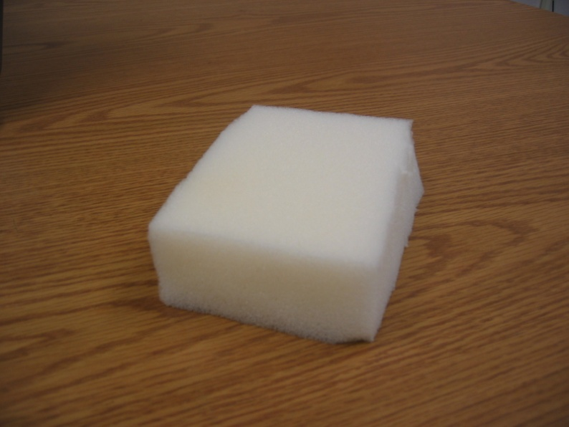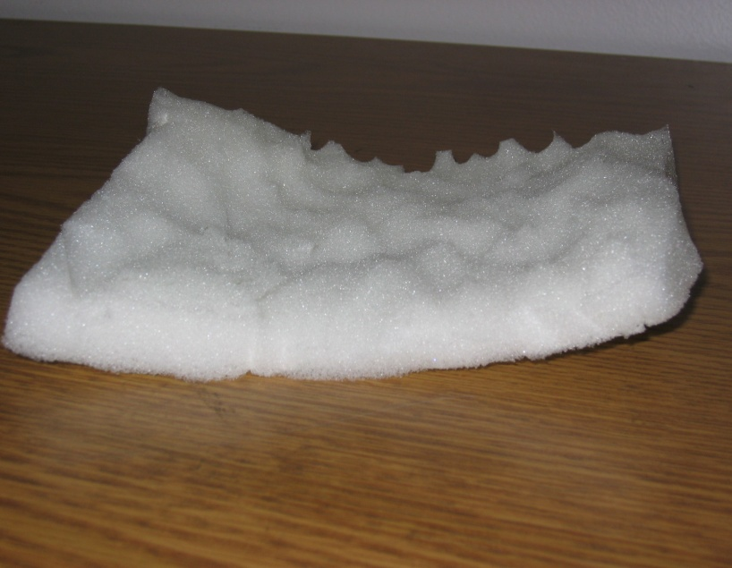
(Note: The cut in half poly foam does not need to be cut perfectly. It just needs to wrap around the plastic bottle.)
Once the foam is cut, you will then place it inside the plastic container as shown below. As mentioned on page 4, you can glue the foam onto the plastic but the glue gun produces VERY HOT GLUE that will melt the plastic container.
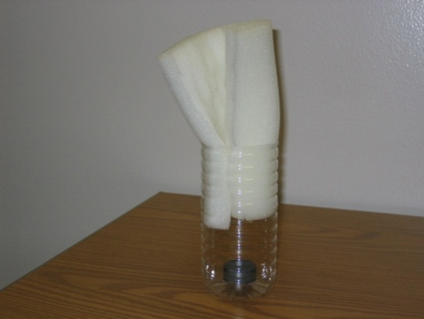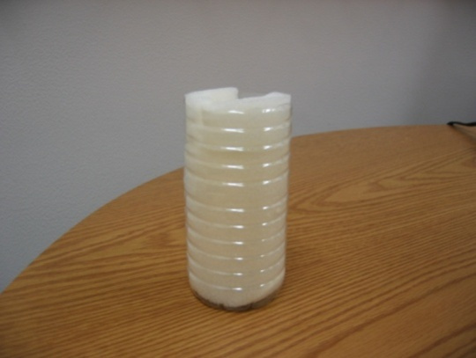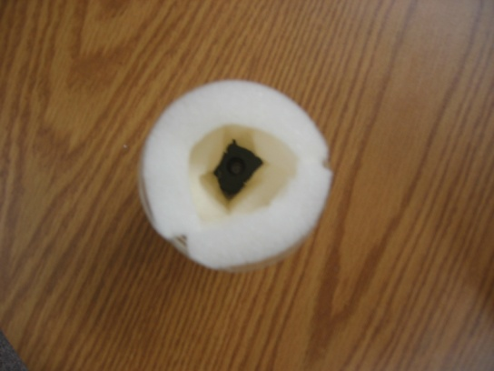
Once the bottle is completed, you will then have glued it onto and inside the container as shown below. The picture on the right (below) side shows the bottom of the kit (I put LOTS of glue inside the container first, than stuck the bottle on top of the glue). Either side of the kit will do. This will give the kit more area space to place additional kit materials.
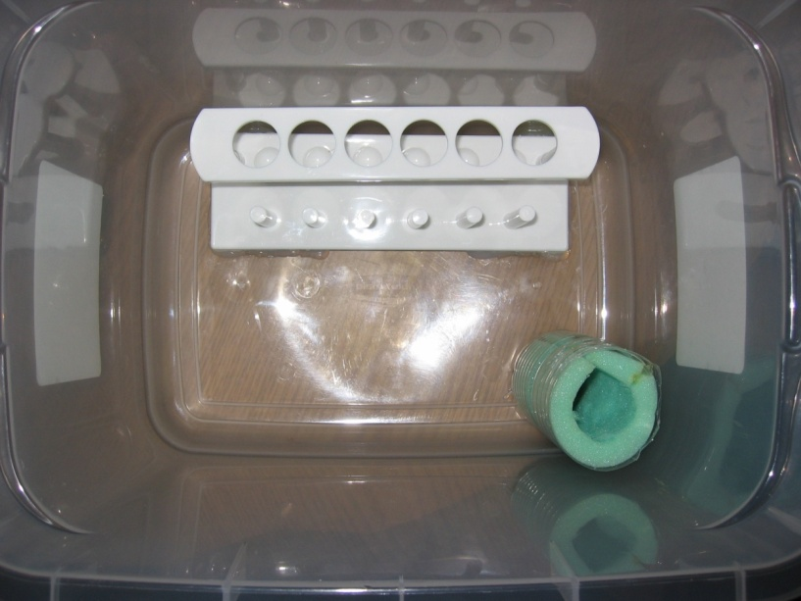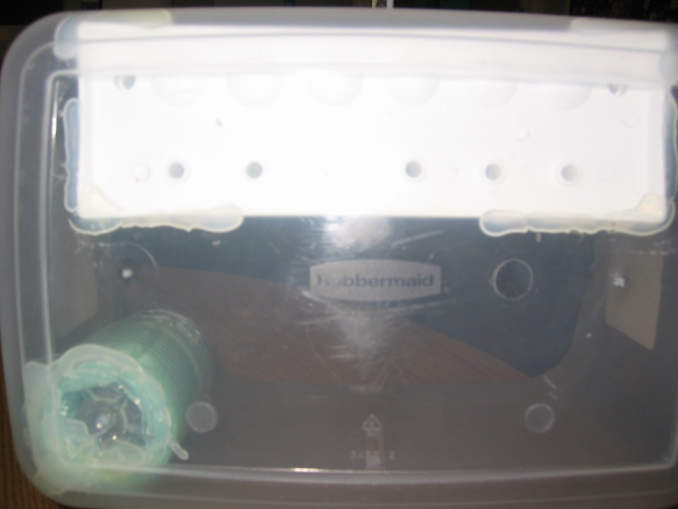
NOTE: These additional pictures (below) will show zoomed versions from the previous pictures to show you how additional glue might be needed to secure the perform rack and bottle. The black arrows and circles indicate where additional glue may need to be placed.
(Note: Again, PLEASE be careful when handling a glue gun because it is extremely HOT.)
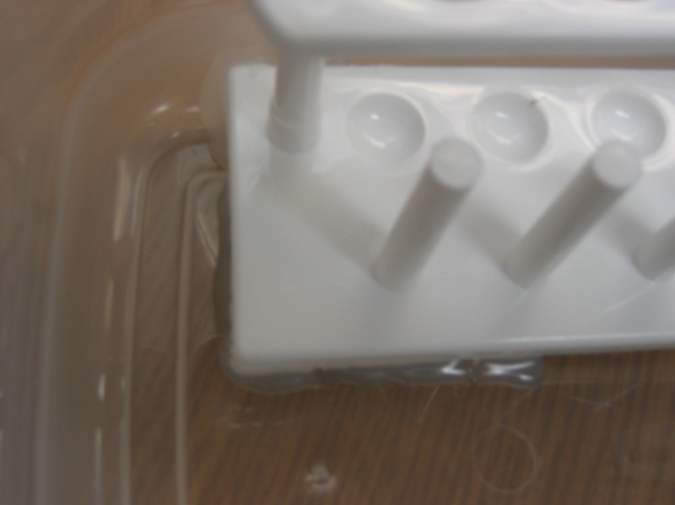
Next, we will discuss how to insert the Gold and Silver Leaf into the 30mL tubes (items shown below).
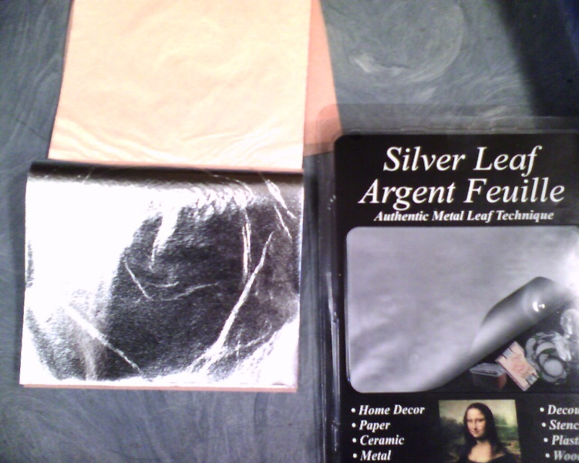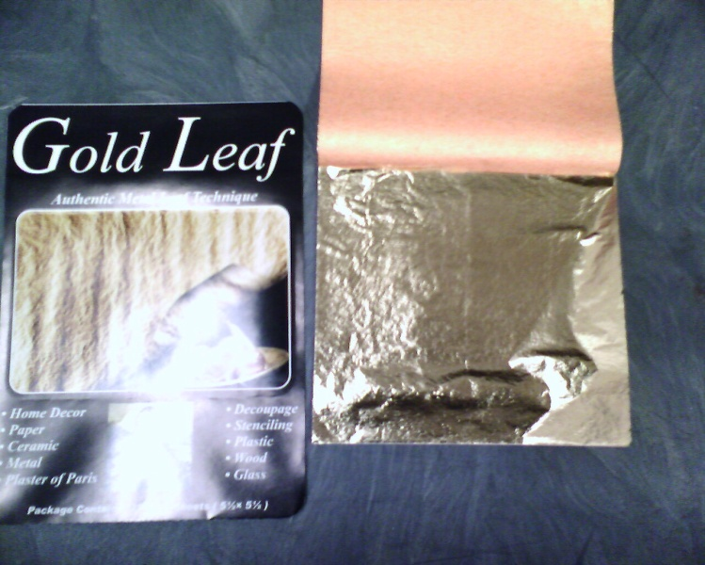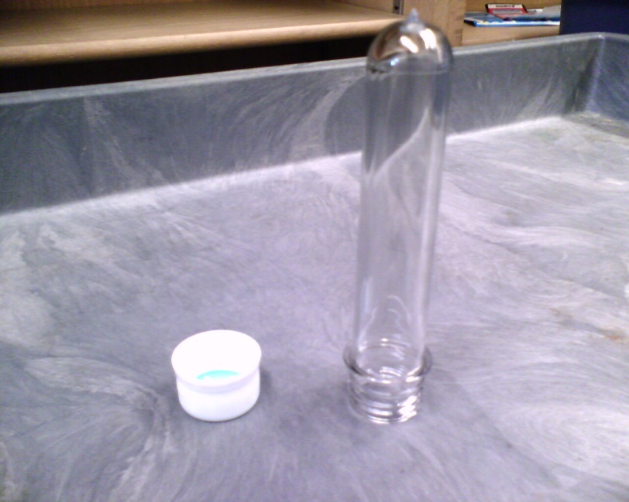
It’s a little difficult to get gold leaf and silver leaf into the tubes. Please see the pictures below that show how to place the gold leaf and silver leaf into the tubes without tearing them.
First, you will need a large paperclip. You will then extend the paperclip to make it straight. Then, bend a small hook at one end of the paperclip as shown below.
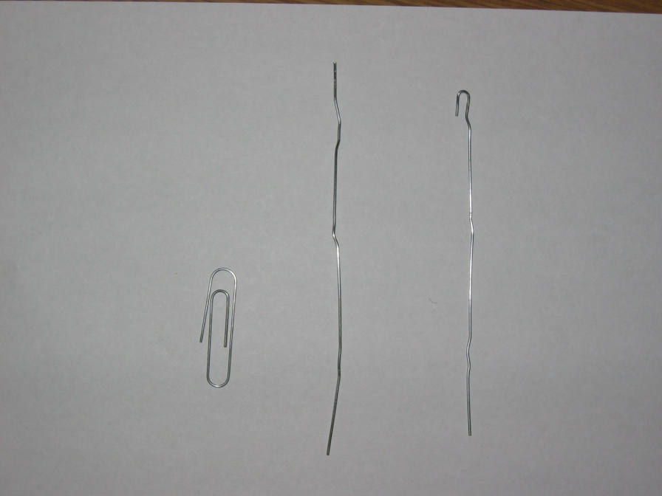
The hook will then be your guide to wrap up the leaf. It should be place under the leaf (shown left, the paper on top (peach color) will keep the leaf stable because it is very sensitive with any type of movements). The hook will help the foil wrap up and the following pictures will give you an understanding on how I managed to complete it.
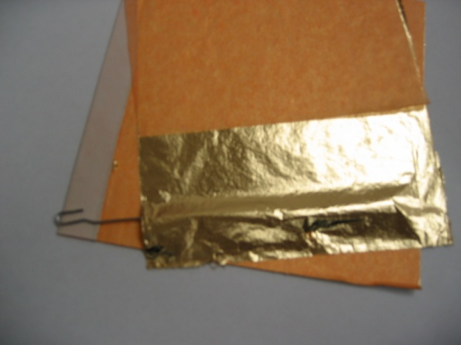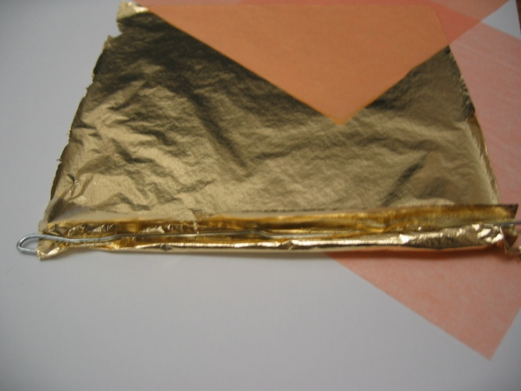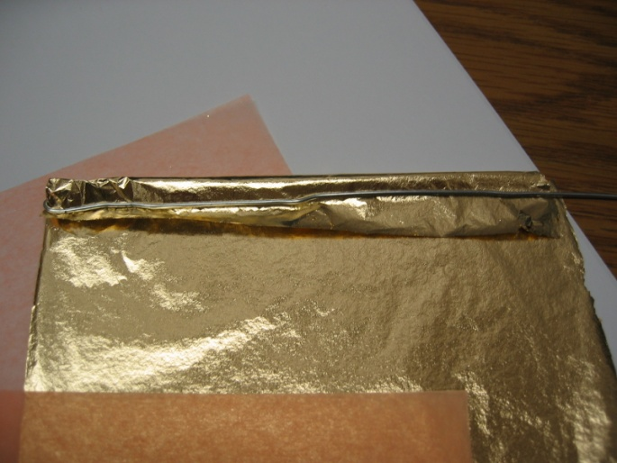
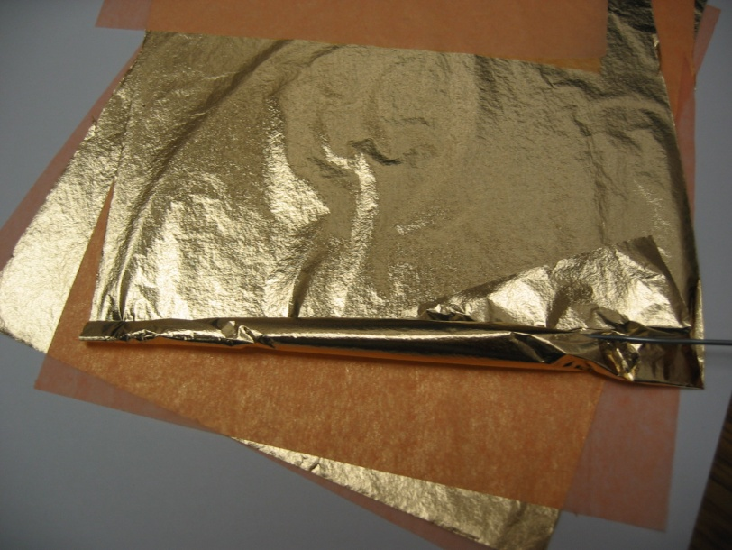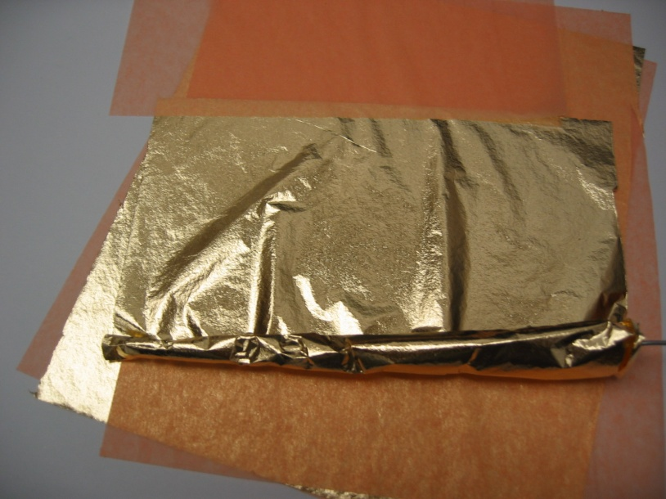
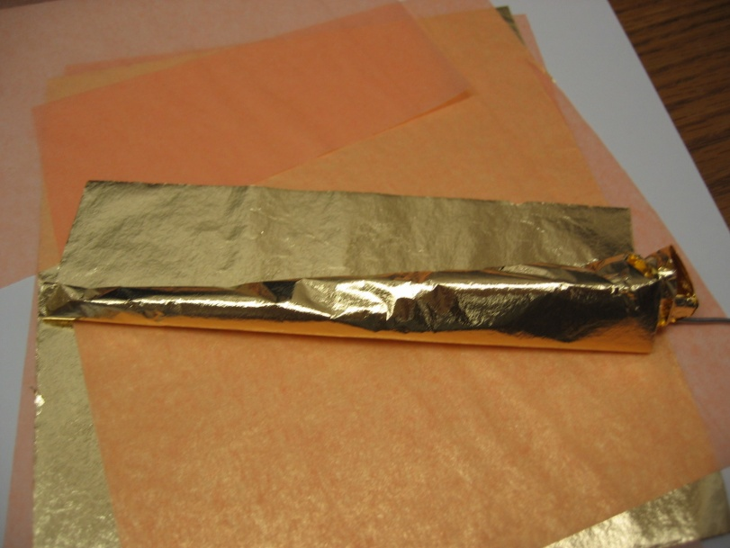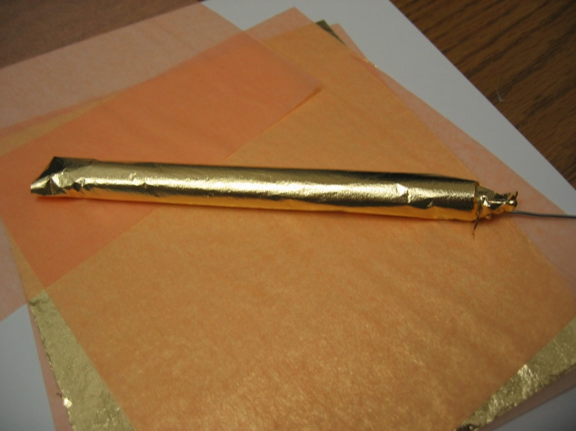
Once the leaf is completely wrapped, you will then insert into a preform tube as shown below:
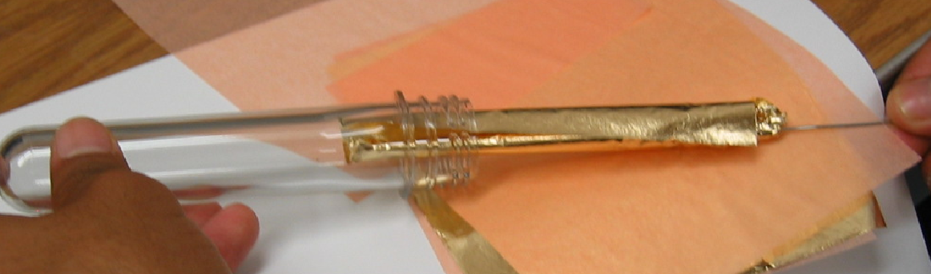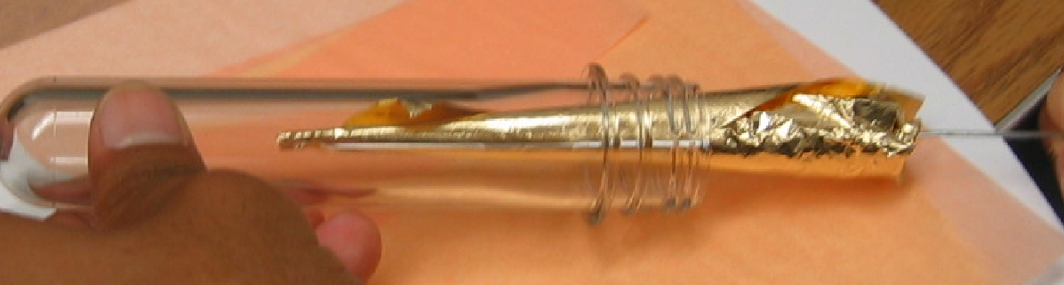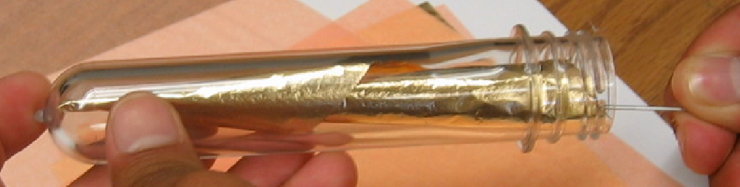
Taking the paper clip out is a tough because the hook part is being inserted down. The easiest way to take out the clip is to unwind it and pull out really slowly. Remember this paper can easily tear and if you pull without being careful, it can crumble the leaf. The cap must be placed on the tube as shown below. The following pictures will show the completed version or taking the clip out and what the final picture should look like:
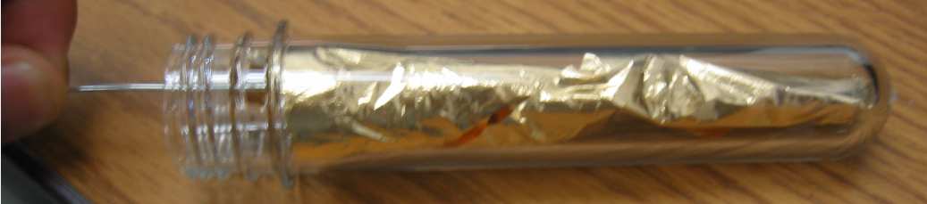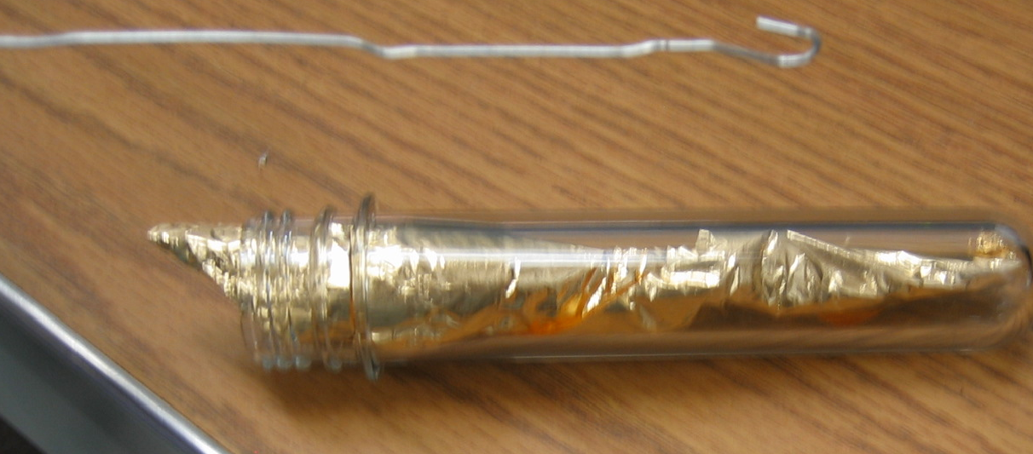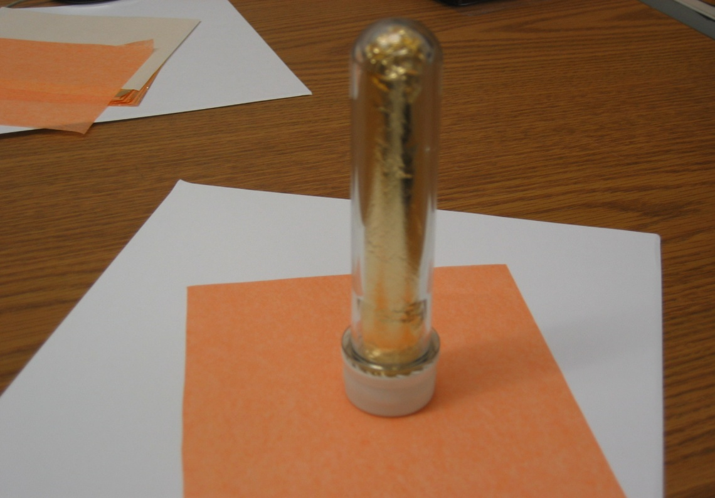
The Sliver leaf can be done with the same procedure as above.
(Note: The hook for the paper clip may not show, depending on how you wrap it.)
The next item discussed will be the chicken wire “nanotube” display model. The pictures on the following page will show guidance to construct the magnified tube using plastic zip-ties. (The plastic chicken wire product will be provided on the last page for information as to where it was bought.)

The chicken wire (next page) “nanotube” display varies in dimension of size.
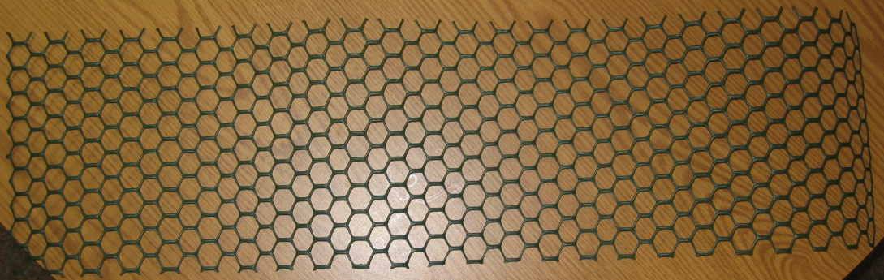
The dimensions we used are 43.4 mm in length and 22.4 mm in height (shown below).
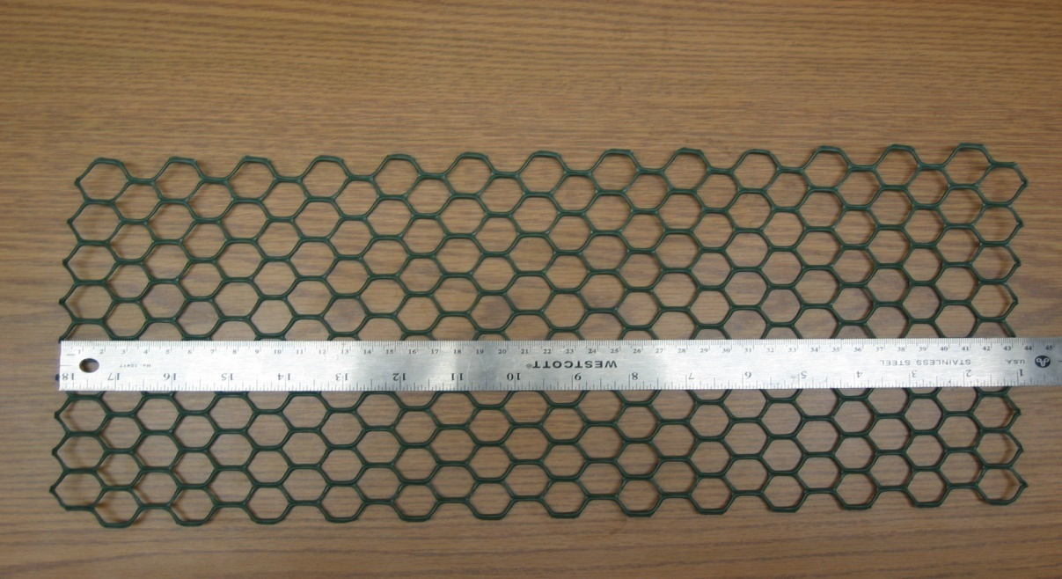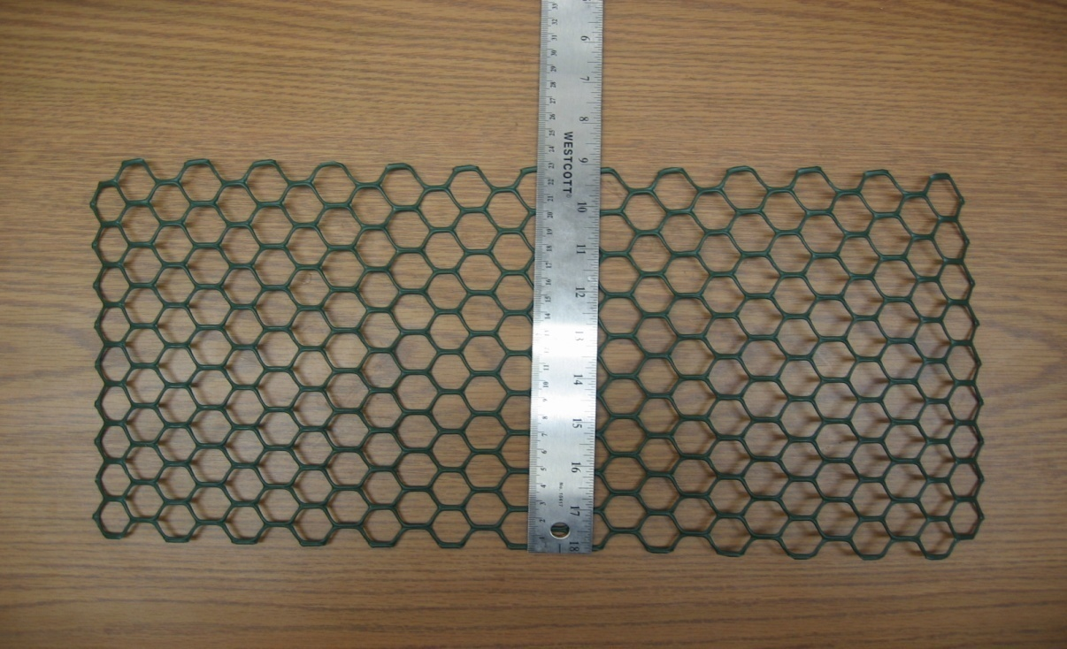

Once you have the measurements, you will then roll up the wire in a “tube like” fashion (shown next page; top left) and apply the zip-ties (shown next page; top right) so that the wire could stay in place (shown next page; bottom left and right).
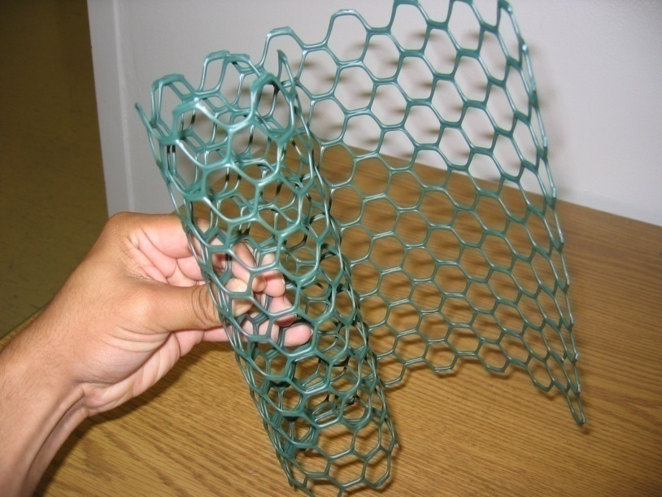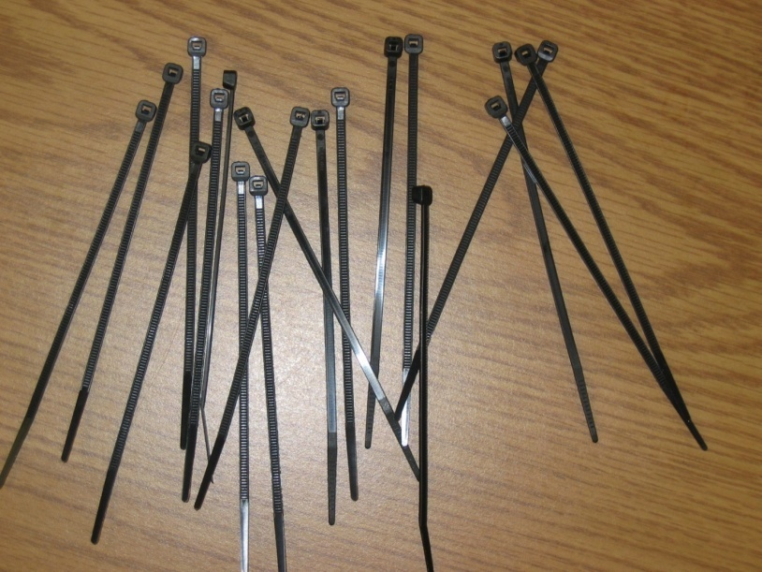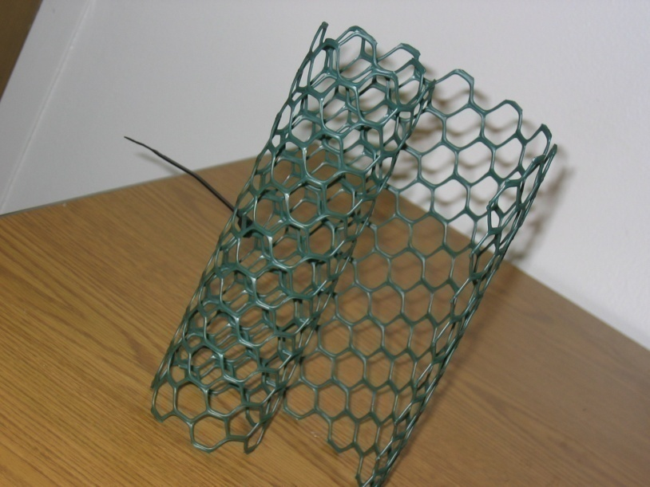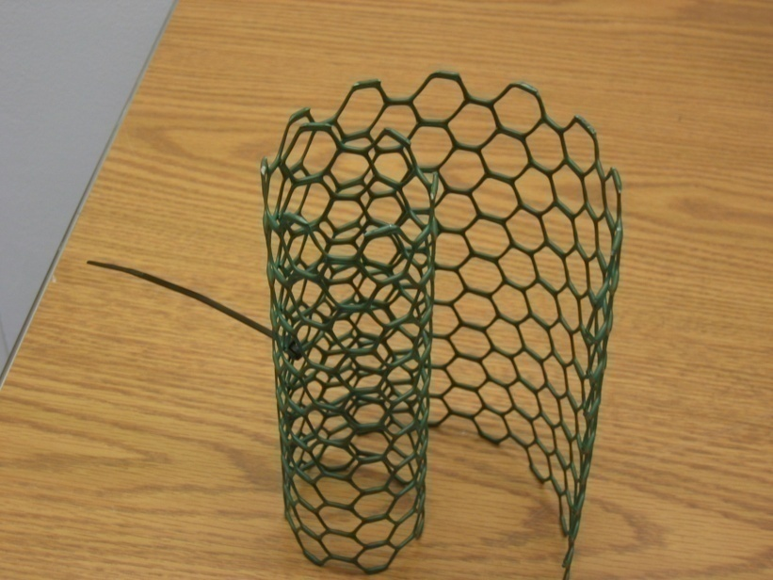
Note: It is better if you line up the hexagon shapes while rolling up the chicken wire because we are constructing an “armchair” carbon nanotube display model. The black zip-ties have no significant background, only meant for holding the wire in place.
Once you have finished rolling up the wire and aligning the hexagonal shapes, you should have a finished display on the next page:

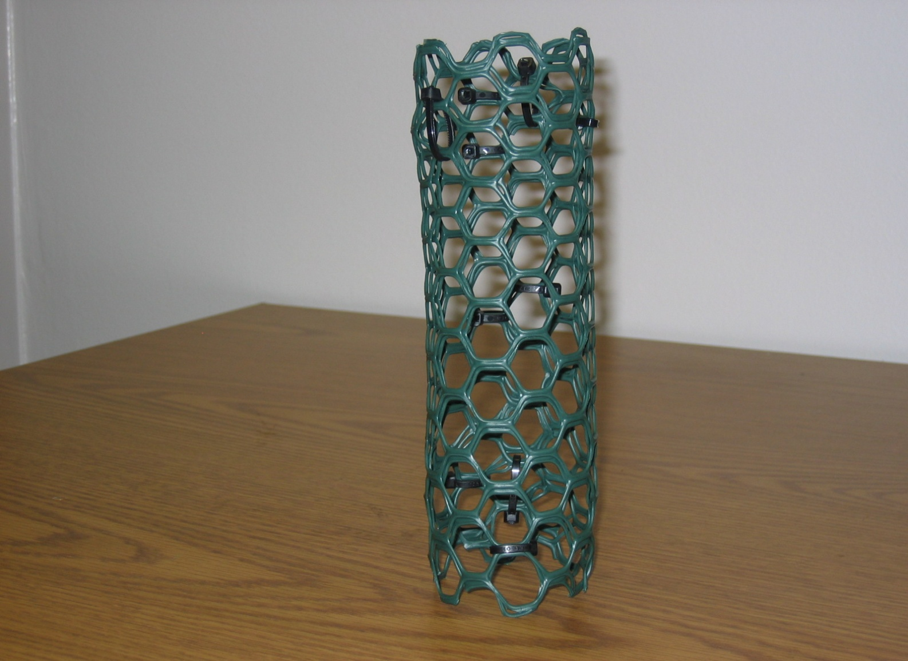
(Note: It does not matter how many zip-ties you use. Just make sure to use enough to keep the tube display from moving. The picture above has 10 zip-ties.)
The diameter of the “nanotube” display (below) is measured at 6.4 mm.
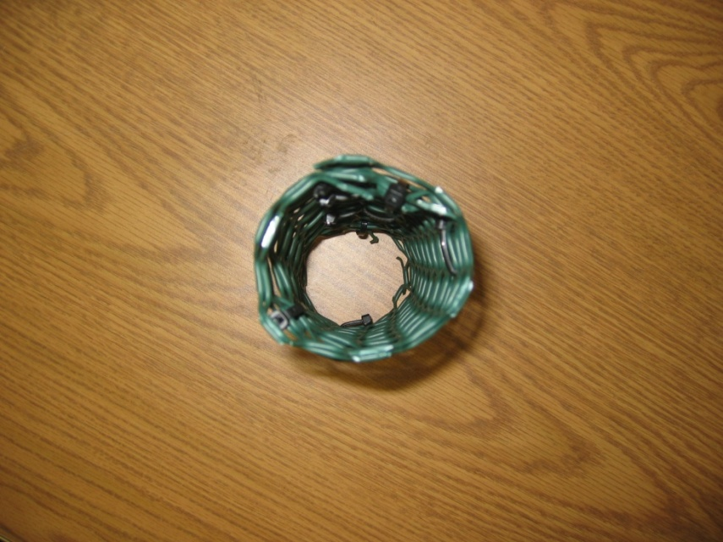

The last item that requires physical work will be the Lego “gold” block display. I will show and discuss two versions of the “gold” block. The first block explained is our “first” prototype on the left. The “second” prototype is on the right. Each block is constructed as shown:
7 – 4x6 plates (shown below) 14 – 2x6 plates (shown below)
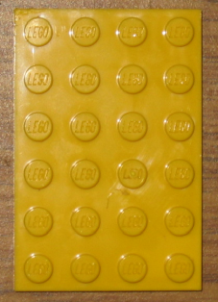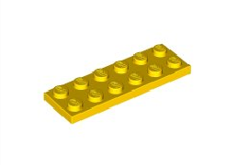
5 – 2x6 bricks (shown below) 5 – 2x6 bricks (shown below)
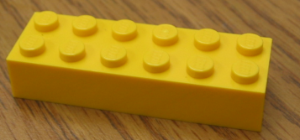
1 – 2x4 brick and 1 – 2x2 brick (shown below) 1 – 2x4 brick and 1 – 2x2 brick (shown below)
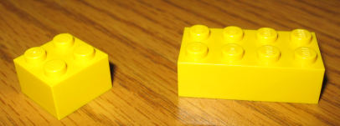

Each prototype (first and second) has the same measurements of 9.55 mm of length, 6.4 mm in width, and 1.3 mm in height (pictures shown below):
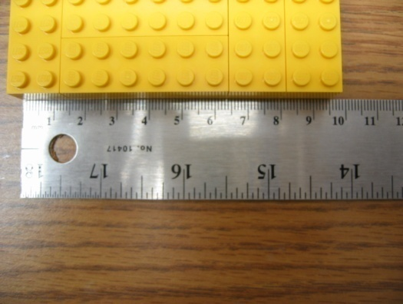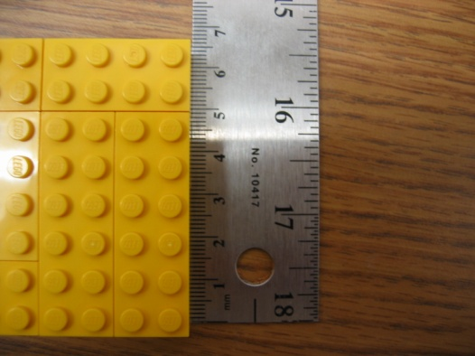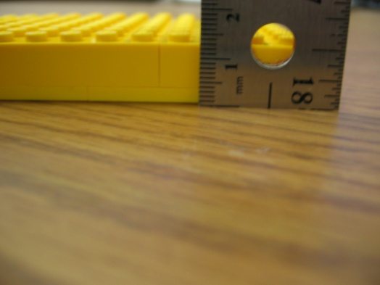

The following pictures (below and the next page) will be the completed versions of the two prototypes mentioned from the previous page. These Lego blocks were also glued together and will show the bottom and top view of each block.
“First” Prototype:
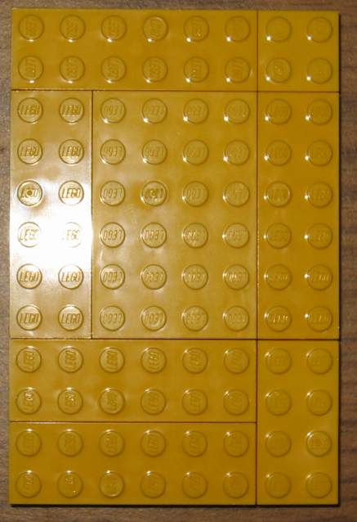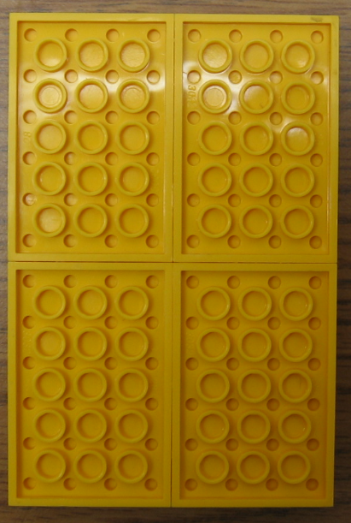
3 – 4x6 plates glued together The “first” prototype block is supported by 4 – 4x6 plates.

And here is the “second” prototype:
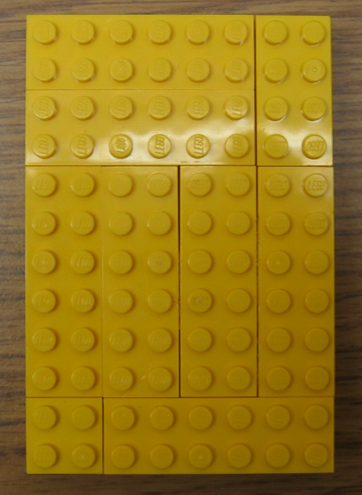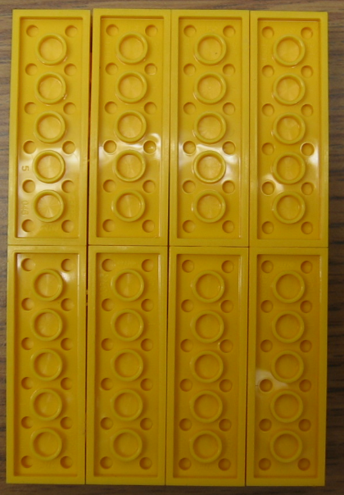
This is where 6 – 2x6 plates were used instead of the 4x6 plates. The bottom portion of the block (right picture above) is where 8 – 2x6 plates and holds the bricks used in the same format from the previous page. It will then be place in a zip lock bag with the following legos’: 1-2x6 brick, 1-2x4 brick, 1-2x2 brick, 1-1x2 brick, 1-1x1 brick, 2-1x1 plates and 1-1x1 plate.
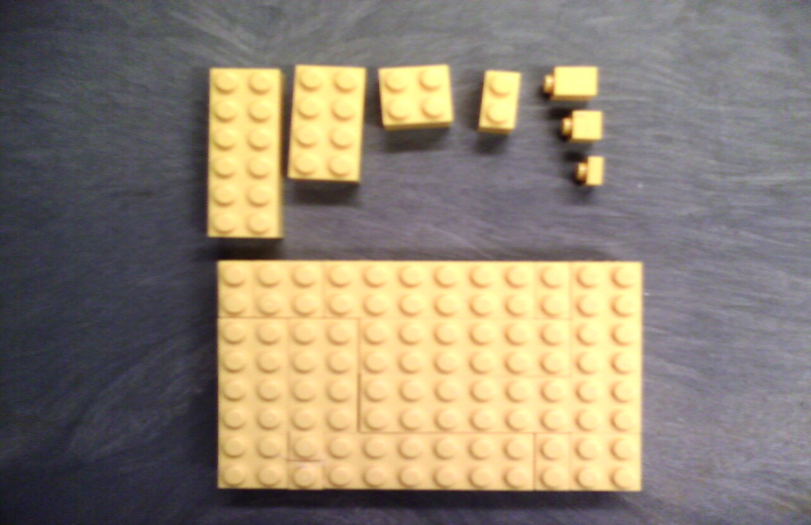
This is final step for constructing anything for the kit. The rest of the items that will be discussed in the next pages will be going inside the kit and will be an easy task.
The first item will be the nanogold and nanosilver liquid (500mL is each bottle) inside the 30mL preform tubes (below).
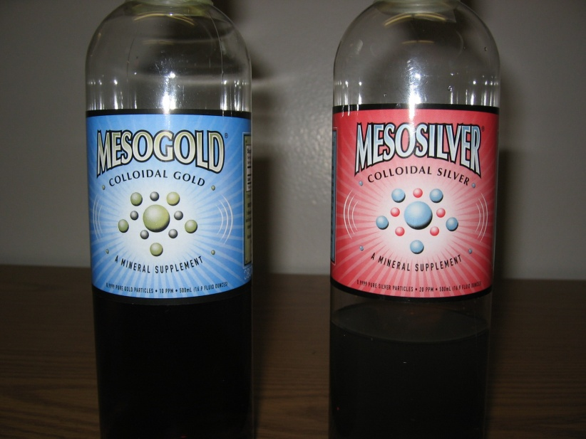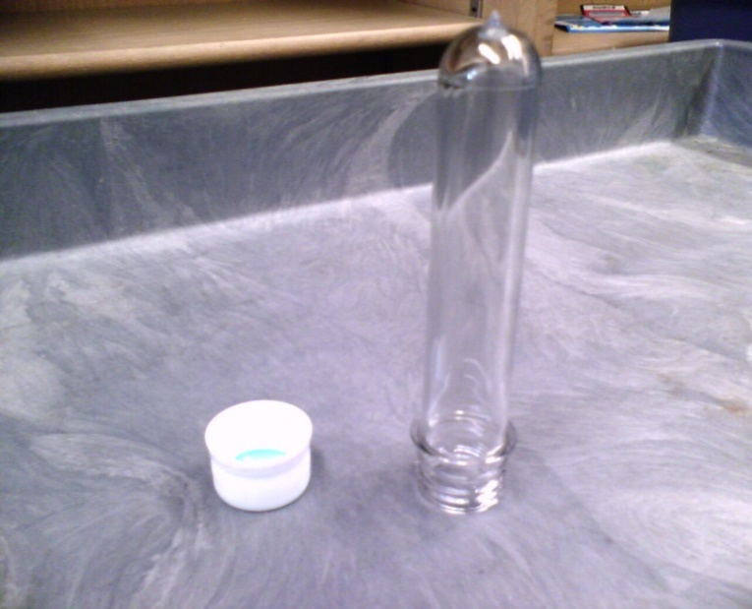
Pouring the liquid into the preform tubes takes little time. The finished product is shown below with labels, that each have “DO NOT OPEN!!!!” on the cap. For the Gold liquid preform tube, the label reads “Colloidal Gold -- 3 to 4 nm (claimed) Purest Colloids (100% gold atoms)”. For the Silver liquid preform tube, the label reads “Colloidal Silver -- 0.65 nm (claimed) Purest Colloids (75%/25% ratio Silver/Silver ion)”.
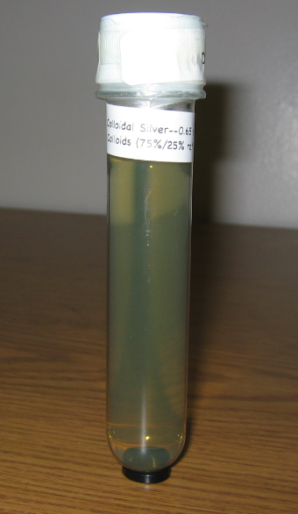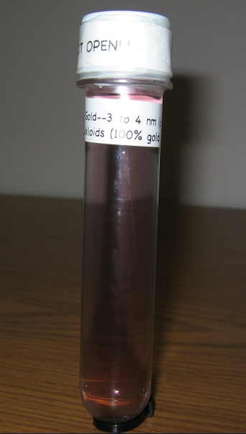
Silver liquid Preform Gold liquid Preform
There will be 40 whole and 40 small strips of magnets (below) that will be given out and collected at the end of the demo:
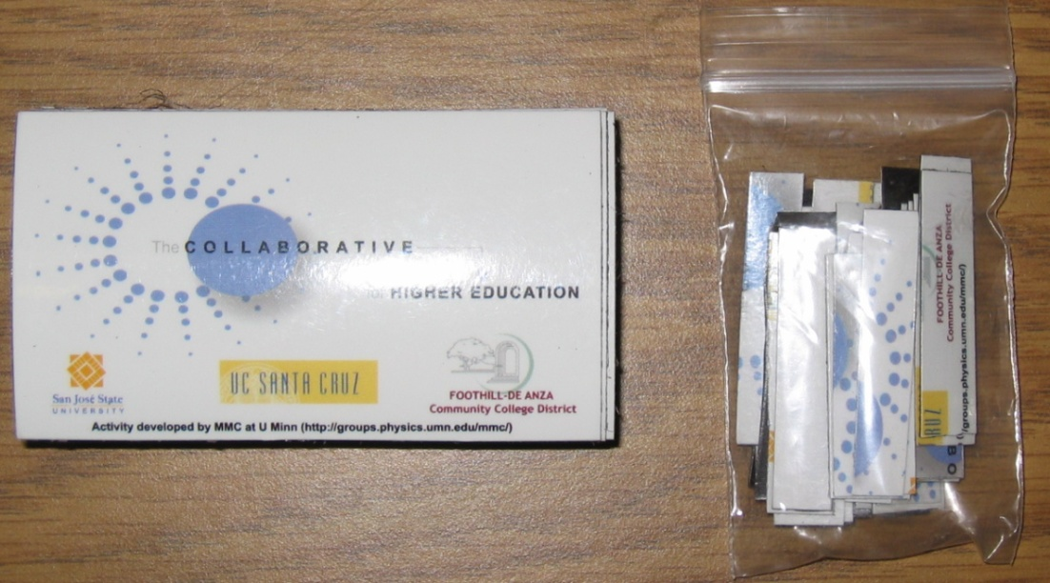
The strips are created by cutting out the whole magnet (below) horizontally FIRST, then in half SECOND.
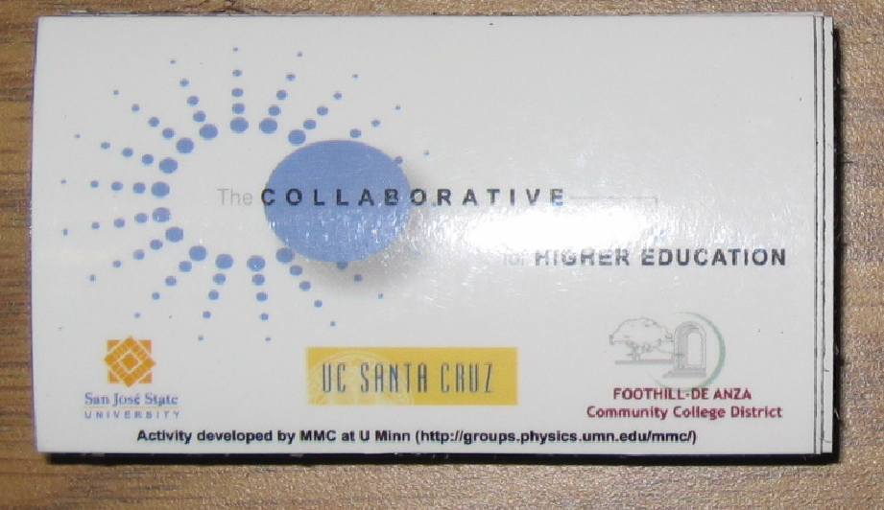
Note: If you cut the magnet vertically first, the strips will be useless because of the magnetic field for this magnet is “side to side” not “up and down”.

These next few items will go inside the kit for educational use and provide the kit with more informational background in what we are trying to accomplish.
The solar cell kit (bottom left) will be place into a zip lock bag with a booklet, cell, motor, and propeller. Two extra circular ceramic magnets in a small “bagettes”(also known as tiny Ziplocs bags) will be used for the Ferrofluid.
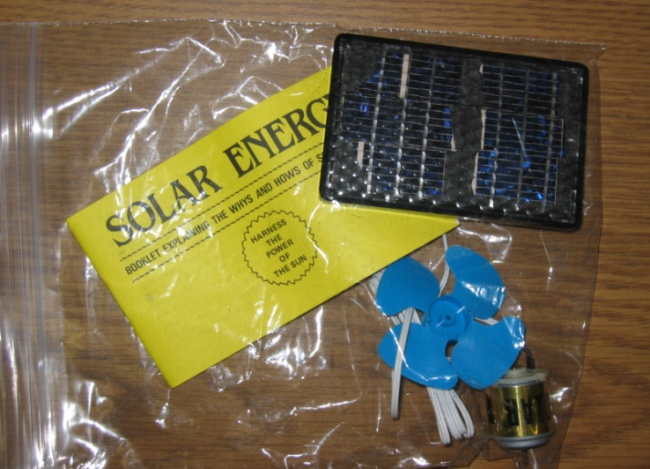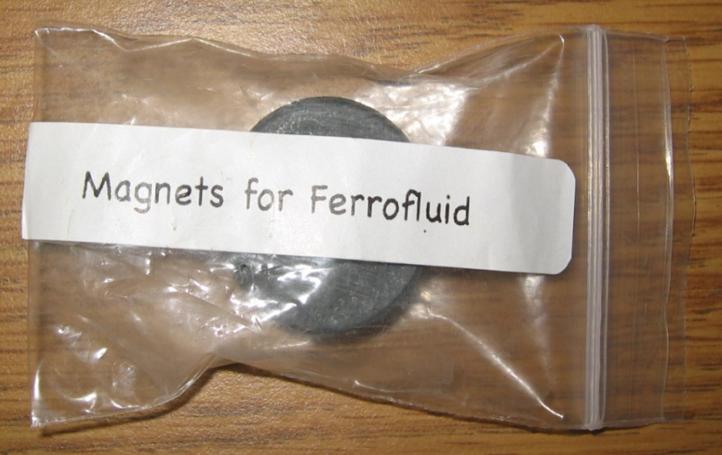
The “one nanosecond” bar (below left) shows the distance to a length light travels in one nanosecond. The label shown on the bag reads “Size and Scale Lesson”. The Ferrofluid (below middle) is inserted into the plastic bottle cut out with poly foam (mentioned earlier in this manual) cap down first. The last item will be the DVD “Power of Ten” and CD (bottom right) that contains the PowerPoint presentation. The labels on the DVD box cover reads “Collaborative in Higher Education Nanotechnology Education Kit” and “Size and Scale Lesson”.
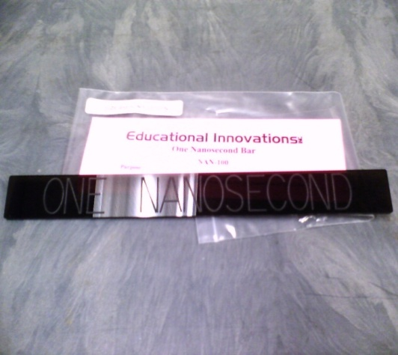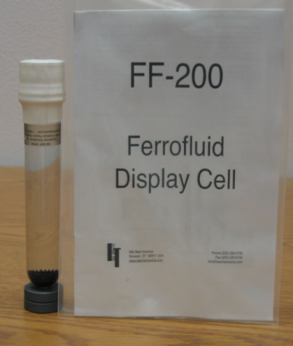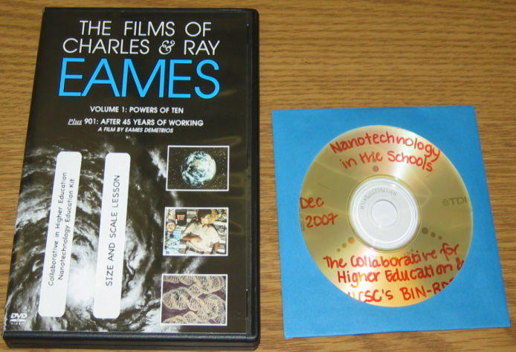
That concludes the “how to make a nanotech kit”. The following picture on the next page will give you a final look on what goes inside and completes the nanotech kit:

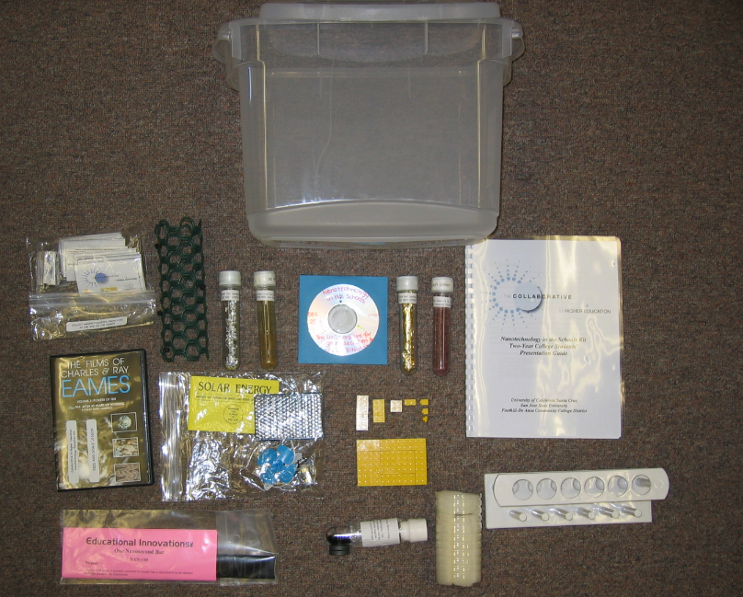
Display of Nanotechnology Kit Materials

MATERIALS LIST: Items are listed in order that they are needed for kit.
ITEM | VENDOR | QUANTITY for Kit
Hot glue gun with glue sticks | Art supply store | 1
19 Liter Rubbermaid Container | Target | 1
Preform Rack (#TT-100) | Education Innovations, Inc. www.teachersource.com | 1
Ferrofluid Display Cell (#FF-200) | Education Innovations, Inc. www.teachersource.com | 1
Ceramic Rings 1.25" in diameter with a .375" hole (#M-715) | Education Innovations, Inc. www.teachersource.com | 2
Poly Foam Roll (2"X22"X22") | Fabric or art supply store | Fraction of roll
Preforms with caps (#SM-100A) | Education Innovations, Inc. www.teachersource.com | 4
Gold leaf | Art supply store | 1 page
Silver leaf | Art supply store | 1 page
Large paper clip
Mesogold 10 ppm (we purchased 500mL bottle) | Purest Colloids, Inc. www.purestcolloids.com | 30 mL
Mesosilver 20 ppm (we purchased 500 mL bottle) | Purest Colloids, Inc. www.purestcolloids.com | 30 mL
Plastic Chicken Wire (will be a large roll that can make many nanotubes) | Hardware store | See directions in manual
Plastic zip ties | Hardware store | See directions in manual
Yellow Legos | www.lego.com (custom Lego order) | See actual # in manual (depends on prototype)
Refrigerator Magnets | Purchase from on-line custom magnet store--you can create your own design | 48 per kit
One Nanosecond Bar (#NAN-100) | Education Innovations, Inc. www.teachersource.com | 1
Various size plastic bags with closures ("Zip-lock" type) | Grocery stores; tiny bags were purchased from a craft store | See manual illustration on p. 19
DEMOKIT Solar Kit | www.siliconsolar.com | 1 kit
The Films of Charles & Ray Eames-The Powers of 10 (Vol. 1) | www.amazon.com | 1 DVD
This kit costs approximately $150 in supplies as of Spring 2008. The contents for the presentation can be found at www.nanosense.org or by e-mailing Maureen Scharberg.

